Manual for LIVE Tool

1 Introduction

This manual will help you work with the LIVE Tool developed for the LIVE Game Design project. The purpose of this tool is the creation of Micro-Machination diagrams, simulation of game economies and the adaptation of game mechanics in real time.

2 Visual Guide

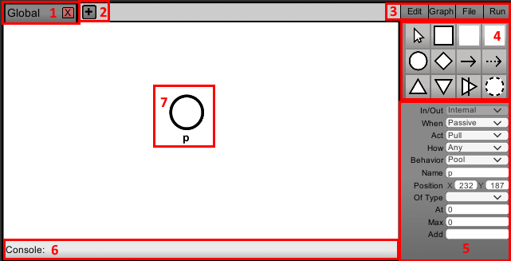

1: Definition tab, click tab to select this definition, click again to rename, click the X button to delete this definition.

2: Add definition button, click this button to add a new definition.

3: Editor bar, select the functionality displayed in the right hand side of the screen. Edit to edit your definitions, Graph (currently unused), File to import and export files, Run to simulate your diagram.

4: Editor properties, functionality changes depending on the selected bar, in this example the Edit bar is selected, here you can add new nodes and edges to the diagram.

5: Editor inspector, functionality changes depending on the selected bar, in this example the Edit bar is selected, here you can change the properties of selected nodes and edges.

6: Console (currently unused), in the future this should report issues with the importing, exporting, simulating and building of diagrams.

7: Diagram objects, these elements form your diagram.

3 Usage

The tool was designed to be used either standalone as a separate program, outputting micro-machination diagrams or as an overlay for a game during development. In its current state it is recommended to use the tool as a standalone program and use the micro-machination diagrams it can create for your game.

To export a diagram go to File > Export and choose a path, the program will create a text document containing the diagram in the chosen location.

To import a diagram go to File > Import and choose a path, the program will read the chosen document and load the corresponding visual diagram.

When using the tool as an overlay during development of your game, you can go to File > Return to Game to disable the tool or use CTRL + M to enable or disable the tool at will. In your game you can press CTRL + M to enable the tool, please note that the tool cannot pause your game, if this is desired this functionality needs to be added to your game separately.

To create a diagram, first press the + button in the top left corner. This will create a definition called Global. The first definition in each diagram is always called Global. Once you have a definition you can go to Edit and click on one of the icons on the right hand side of the screen. This will select one of the objects as your active object. Now you can click anywhere on the definition to place an object of the selected type. The new object will automatically be the selected object, and new options will appear under the type selector on the right hand side of the tool. Here you can change properties of the node or edge you just placed. Please note that some properties are grayed out, these properties cannot be changed.

To learn more about what each property does or what all node and edge types mean, please refer to documentation about the Micro-Machinations language by Riemer van Rozen. References to this documentation can be found in my Thesis.

4 Keyboard Shortcuts

**CTRL + M**: Toggles the tool on or off (useful when integrating the tool into a game)(location in code: ToggleTool.cs)

**CTRL + A:** Adds new definition (tab) (location in code: TabManager.cs)

**CTRL + C:** Copy (copies selected node) (location in code: ModelViewController.cs)

**CTRL + V**: Paste (pastes current copied node) (location in code: ModelViewController.cs)

**CTRL + X**: Cut (copies selected node & deletes it) (location in code: ModelViewController.cs)

**Tab**: Cycles definitions (tabs) (location in code: Tabmanager.cs)

**Delete**: Deletes selected object (nodes/edges) (location in code: SelectNodeButton.cs & SelectEdgeButton.cs)

If you wish to use any of these shortcuts for other purposes, the locations of the checks are listed here so you can easily change the function or remove the code of the current function.